# Steps to Create a New Practice Site

* Save template site and include content
  + Goshen Template (can Goshen be regarded as a dev site?)
  + Note: The maximum total file size limit is 52,428,800 bytes. If exceeded, consider:
    - Deleting unneeded Print Jobs
* Creating new site from the site template
  + First create the appropriate Site Users Group in the EMR root site e.g. Goshen Users
    - Permissions should be just EMR_Root_Site_Access
    - To see Groups Permissions go to Site Settings => Site Permissions
  + Can create site with unique permissions, will get prompted for groups etc. or create site inheriting permissions and then in Site Settings => Permissions select Stop Inheriting Permission in ribbon
  + How to set up Permissions in new sub site (see below for more details):
    - Go to Site Settings => Permissions
    - Stop inheriting permissions (if set), then accept defaults in dialog.
    - Use Remove User Permissions to remove unwanted groups
* Other Tasks
  + Add practice to root site Practices list
  + Add appropriate Forms to Practice list item and edit Form Sets in the Schedules list
  + Set up Site Logo (upload logos to /EMR/SiteAssets)
  + Fix the description in the Top Link Bar (i.e. should be Maternal Child Health)

Site Settings => Permissions looks like this:

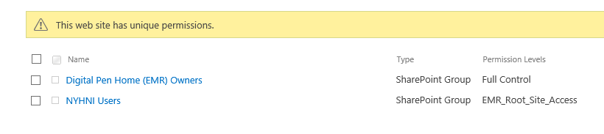

Site Settings => People and Groups

Then Click on More… looks like this - DON’T DELETE groups from this list since it deletes them throughout entire site collection

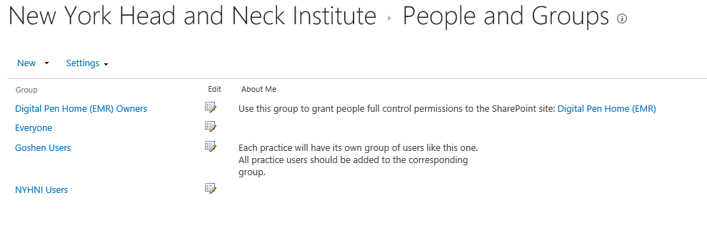

Need to set up permissions (currently) for the Forms, Schedules

To **see** permissions use Site Settings => Permissions then click on “Show these Items” to get this

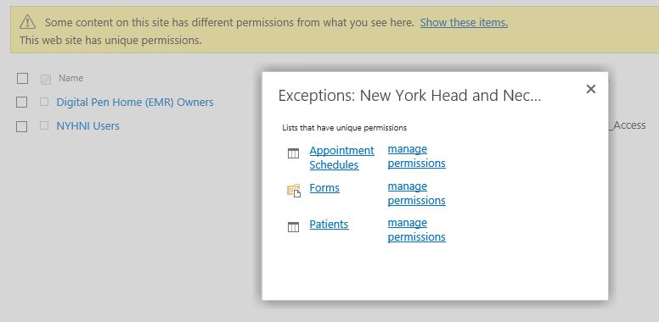

or for more detail for a specific group do the following: Site settings => Permissions, select the group via the hyperlink then select Settings => “View Group Permissions” to see:

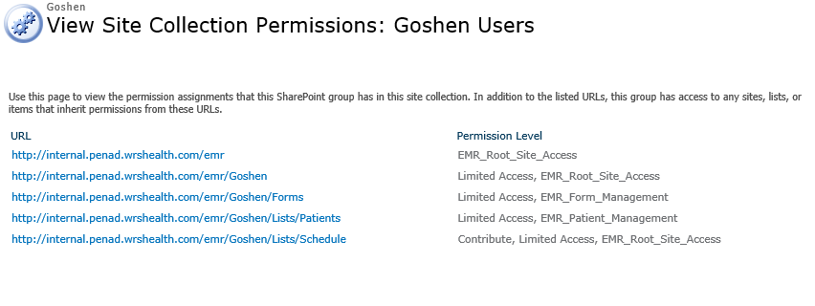

Go to permissions for each list and stop inheriting permissions from the parent.

As soon as specific access is enabled for the User Group e.g. to the Forms list - the permissions for that group change to include “Limited Access” in the Permissions => Edit Permissions ribbon button for that group as below:

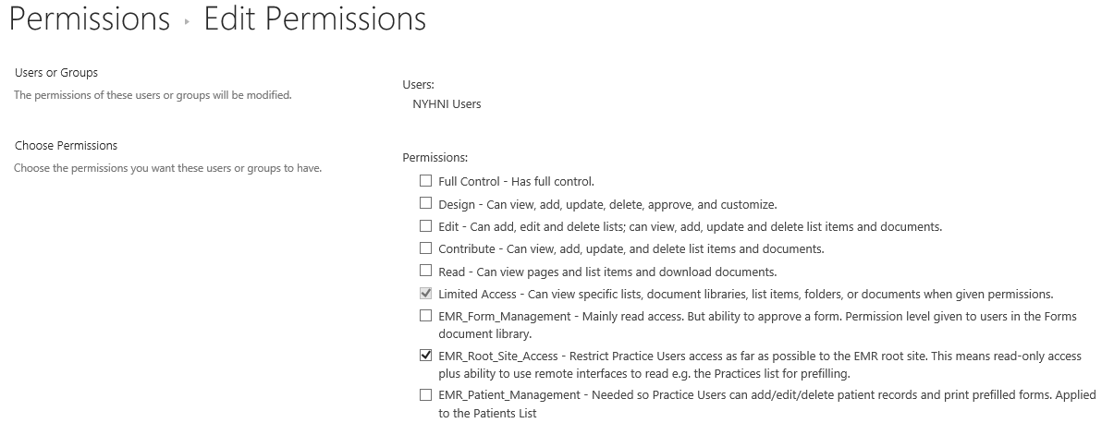

## To Add Existing FBA users to the New NYHNI FBA group

In the “Add people to the NYHNI Users Group dialog” need to paste in the FBA internal name of the user e.g. |owaisiqbal i.e. part of i:0#.f|sql_membership|owaisiqbal